Dog Breed Identification using Transfer Learning

- INTRODUCTION:
Dog breed identification plays an important role in pet adoption, veterinary care, and animal welfare initiatives. Accurate identification of dog breeds helps in understanding breed-specific health conditions, behavioural traits, and care requirements. However, identifying dog breeds based solely on visual appearance is often challenging, especially in the case of mixed breeds or breeds with similar physical characteristics. Misidentification can lead to inappropriate care decisions and delays in adoption processes.
Traditional dog breed identification relies on manual observation and expertise from veterinarians, breeders, or experienced pet handlers. This manual approach is subjective, time-consuming, and prone to human error. In many shelters and rural regions, access to trained professionals is limited, making it difficult to provide reliable breed information to potential adopters or pet owners in a timely manner.
With the rapid advancements in Artificial Intelligence and Computer Vision, image classification systems have become increasingly accurate and efficient. Convolutional Neural Networks (CNNs) have demonstrated strong performance in extracting visual patterns from images. Transfer learning models such as VGG19, ResNet, and Inception enable high-accuracy classification even when trained on relatively smaller datasets, reducing the need for large-scale data collection.
This project focuses on building a Deep Learning-based Dog Breed Identification System using the VGG19 pre-trained model. The system analyses uploaded dog images and classifies them into predefined breed categories. The model is fine-tuned using a curated dataset to improve prediction accuracy across visually similar breeds.
Additionally, a web-based application is developed using the Flask framework to allow users to upload dog images and instantly receive breed predictions along with confidence scores. The system provides a simple and accessible interface for real-time inference. This project bridges the gap between Artificial Intelligence and animal welfare by offering an automated, reliable, and scalable solution for dog breed identification, supporting pet adoption platforms, veterinarians, and pet owners.

2. Project Overview
The primary objective of this project is to design and develop an AI-based web application that identifies and classifies dog breeds from uploaded images using Deep Learning techniques.
The system consists of two major components:
- Deep Learning Model
- Web Application Interface
The Deep Learning model is built using the VGG19 architecture, a powerful convolutional neural network pre-trained on the ImageNet dataset. The model is fine-tuned for dog breed classification and trained on a labeled dataset containing images of multiple dog breeds. Transfer learning is utilized to achieve high accuracy even with a relatively smaller dataset.
The web application allows users to:
- Upload dog images
- View predicted dog breed
- See confidence score for the prediction
- Upload another image for new prediction
- Interact with a simple and user-friendly interface
The system performs image preprocessing including resizing, normalization, and channel dimension adjustment before feeding the image into the trained model. The model outputs probability scores for each breed class, and the class with the highest probability is selected as the final prediction.
Key highlights of the project include:
- Use of Transfer Learning (VGG19)
- Real-time image classification through web interface
- Integration of Flask backend with ML model
- Clean and responsive UI design
- Confidence score visualization for predictions
- Modular and scalable architecture for future extensions
The system provides a practical and accessible solution for automated dog breed identification, supporting pet adoption platforms, veterinarians, and pet owners with accurate and instant breed predictions.

- Architecture:
Absolutely — here’s a polished “Architecture Overview” section you can drop straight into your final report/documentation for the Dog Breed Identification (VGG19 + Flask) project. It’s concise, formal, and matches academic/project-report style:

The Dog Breed Identification System is designed using a modular, three-tier architecture that separates the concerns of presentation, application logic, and machine learning inference. This architectural approach improves maintainability, scalability, and clarity of system components.
Architectural Layers
1. Presentation Layer (Frontend):
The presentation layer provides the user interface through which users interact with the system. It is implemented using HTML, CSS, and JavaScript and allows users to upload dog images and view prediction results along with confidence scores. The UI is designed to be simple, responsive, and user-friendly.
2. Application Layer (Backend):
The application layer is implemented using the Flask web framework in Python. It handles HTTP requests from the frontend, manages file uploads, performs input validation, and orchestrates the end-to-end prediction workflow. This layer also loads the trained deep learning model into memory and manages communication between the UI and the ML inference pipeline.
3. Intelligence Layer (Machine Learning Model):
The intelligence layer consists of a Convolutional Neural Network (CNN) based on the VGG19 architecture, pre-trained on ImageNet and fine-tuned for dog breed classification. This layer performs image feature extraction and classification. The trained model is stored locally and loaded by the backend for real-time inference.
4. Data & Storage Layer:
This layer manages storage of uploaded images, trained model files, and class labels. Local file storage is used for the current implementation, with provision for future integration of cloud storage solutions to support scalability and persistence.
Data Flow and Interaction
- The user uploads a dog image through the web interface.
- The Flask backend receives the image and performs preprocessing (resizing, normalization).
- The preprocessed image is passed to the VGG19-based model for inference.
- The model returns class probabilities for each dog breed.
- The backend formats the result and sends the predicted breed and confidence score back to the frontend for display.
Architectural Benefits
- Scalability: The modular design allows easy extension to cloud deployment and addition of more dog breeds.
- Maintainability: Clear separation of frontend, backend, and ML components simplifies debugging and future enhancements.
- Performance: Preloading the model in memory ensures fast response times for real-time predictions.
- Extensibility: The architecture supports future integration with APIs, mobile clients, or additional analytics features.

4. Setup Instructions
To successfully deploy and execute the Dog Breed Identification System, a proper development environment must be configured. This section provides the steps required to install dependencies, configure the environment, and run the application smoothly.
4.1 Prerequisites
Before setting up the project, ensure the following software and tools are installed:
- Python 3.8 or higher
- pip (Python package manager)
- Virtual Environment (recommended)
- TensorFlow / Keras
- Flask
- NumPy
- Pillow (PIL) for image processing
- Web Browser (Chrome / Edge / Firefox)
For model training (optional):
- GPU-enabled system (NVIDIA CUDA supported) for faster training (recommended but not mandatory)
4.2 Installation Steps
Step 1: Clone the Project Repository
Download or clone the project source code from the repository:
git clone <repository-link>
cd dog-breed-identification
Step 2: Create and Activate Virtual Environment
It is recommended to use a virtual environment to isolate project dependencies:
python -m venv venv
venv\Scripts\activate # Windows
# source venv/bin/activate # macOS/Linux
Step 3: Install Required Dependencies
Install all required Python packages:
pip install flask
pip install tensorflow
pip install numpy
pip install pillow
Alternatively, install all dependencies at once:
pip install -r requirements.txt
Step 4: Add the Trained Model
Place the trained model file, for example:
vgg19_dog_breed_model.h5
inside the root project directory or the designated models/ folder as per your project structure.
Step 5: Configure Application Settings
In app.py, ensure:
- The model file path is correctly specified
- The upload folder path exists
- The list of class labels is correctly loaded
(If you later integrate a database or cloud service, update the corresponding credentials here.)
4.3 Environment Configuration
Ensure the following before running the application:
- The virtual environment is activated
- Required dependencies are installed successfully
- The trained model file path is correct
- The upload directory exists and has proper permissions
- Sufficient disk space is available for storing uploaded images
Once setup is complete, the application can be executed locally using:
python app.py
The web application will be available at:
http://127.0.0.1:5000

5. Folder Structure
A well-organized folder structure ensures maintainability, scalability, and modular development. The project follows a clean architecture separating frontend templates, backend logic, and machine learning components.
project/
│
├── templates/
│ ├── index.html
│ ├── predict.html
│ └── output.html
│
├── static/
│ ├── css/
│ │ └── styles.css
│ └── js/
│ └── main.js
│
├── uploads/
│
├── models/
│ └── vgg19_dog_breed_model.h5
│
├── app.py
│
└── requirements.txt

Explanation of Folders
templates/
Contains all frontend HTML pages rendered using Flask’s render_template() function.
- index.html → Landing page
- predict.html → Image upload page
- output.html → Prediction result display
static/
Stores static assets such as CSS and JavaScript files used for styling and UI interactions.
- css/ → Custom stylesheets
- js/ → Client-side scripts (optional enhancements)
uploads/
Temporarily stores uploaded dog images for prediction processing.
models/
Contains the trained deep learning model file used for inference.
- vgg19_dog_breed_model.h5 → Trained VGG19 model weights and architecture
app.py
Main backend file that:
- Loads the trained VGG19 model
- Handles image upload and validation
- Performs image preprocessing
- Executes breed prediction
- Returns results to the frontend UI

requirements.txt
Lists all Python dependencies required to run the project (Flask, TensorFlow, NumPy, Pillow, etc.).
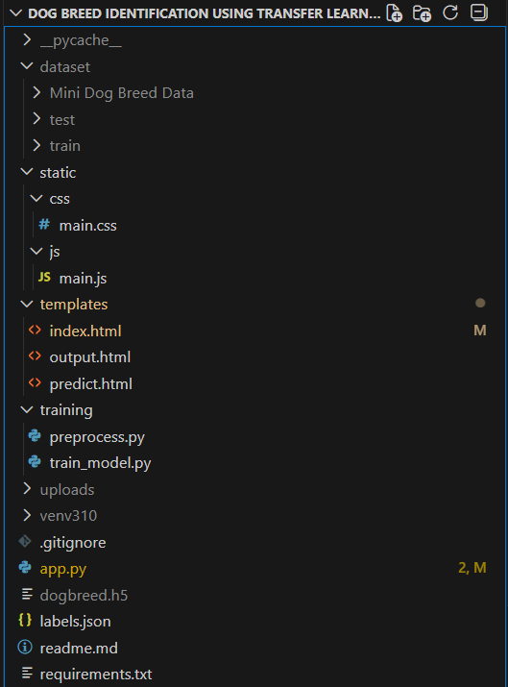
6. Running the Application
Once the setup is complete, the application can be executed locally.
Step 1: Open Terminal
Navigate to the project directory:
cd dog-breed-identification
Step 2: Activate Virtual Environment
venv\Scripts\activate # Windows
# source venv/bin/activate # macOS/Linux
Step 3: Run Flask Application
python app.py
Step 4: Access Application
Open a web browser and enter:
http://127.0.0.1:5000
The application will load the homepage. Users can:
- Upload a dog image
- View predicted dog breed
- See confidence score
- Upload another image for a new prediction
The application runs in debug mode for development and testing. For production deployment, debug mode should be disabled and the application should be hosted using a production-ready server (e.g., Gunicorn) with proper configuration.
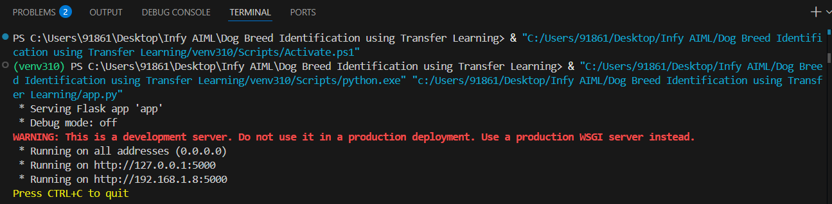

7. API Documentation
The backend provides several REST-like routes handled by the Flask framework to support image upload and dog breed prediction.
1. Home Route
GET /
Description:
Renders the homepage of the web application.
Response:
- Loads the landing page with project overview and navigation to prediction page.
2. Prediction Page Route
GET /predict
Description:
Renders the image upload page for dog breed prediction.
Response:
- Displays the image upload form.
3. Prediction API Route
POST /predict
Description:
Accepts an uploaded dog image, performs preprocessing, and returns the predicted dog breed along with confidence score.
Parameters:
- image (file upload): Dog image to be classified
Response:
- Predicted dog breed
- Confidence percentage
- Error message for invalid or missing image
4. Result Display Route
GET /output
Description:
Displays the prediction result page.
Response:
- Renders predicted breed and confidence score on the UI.
5. Health Check / App Status (Optional)
GET /health
Description:
Returns application status (used for testing or monitoring).
Response:
- Status message indicating the server is running.
Error Handling
Common error responses include:
- Unsupported file format
- Missing image file
- Internal server error
8. User Interface
The user interface is designed to provide a clean, modern, and user-friendly experience for uploading dog images and viewing breed predictions. The UI focuses on simplicity and clarity, ensuring that users can interact with the system without technical complexity.
UI Highlights
- Clean and minimal design suitable for web-based applications
- Image upload interface with preview functionality
- Smooth animations and hover effects for better interactivity
- Clear display of predicted dog breed
- Confidence score visualization (progress bar / percentage)
- Responsive layout compatible with desktop and mobile screens
The interface improves user engagement and enhances usability for pet owners, adoption volunteers, and general users by presenting prediction results in a visually appealing and easy-to-understand manner.

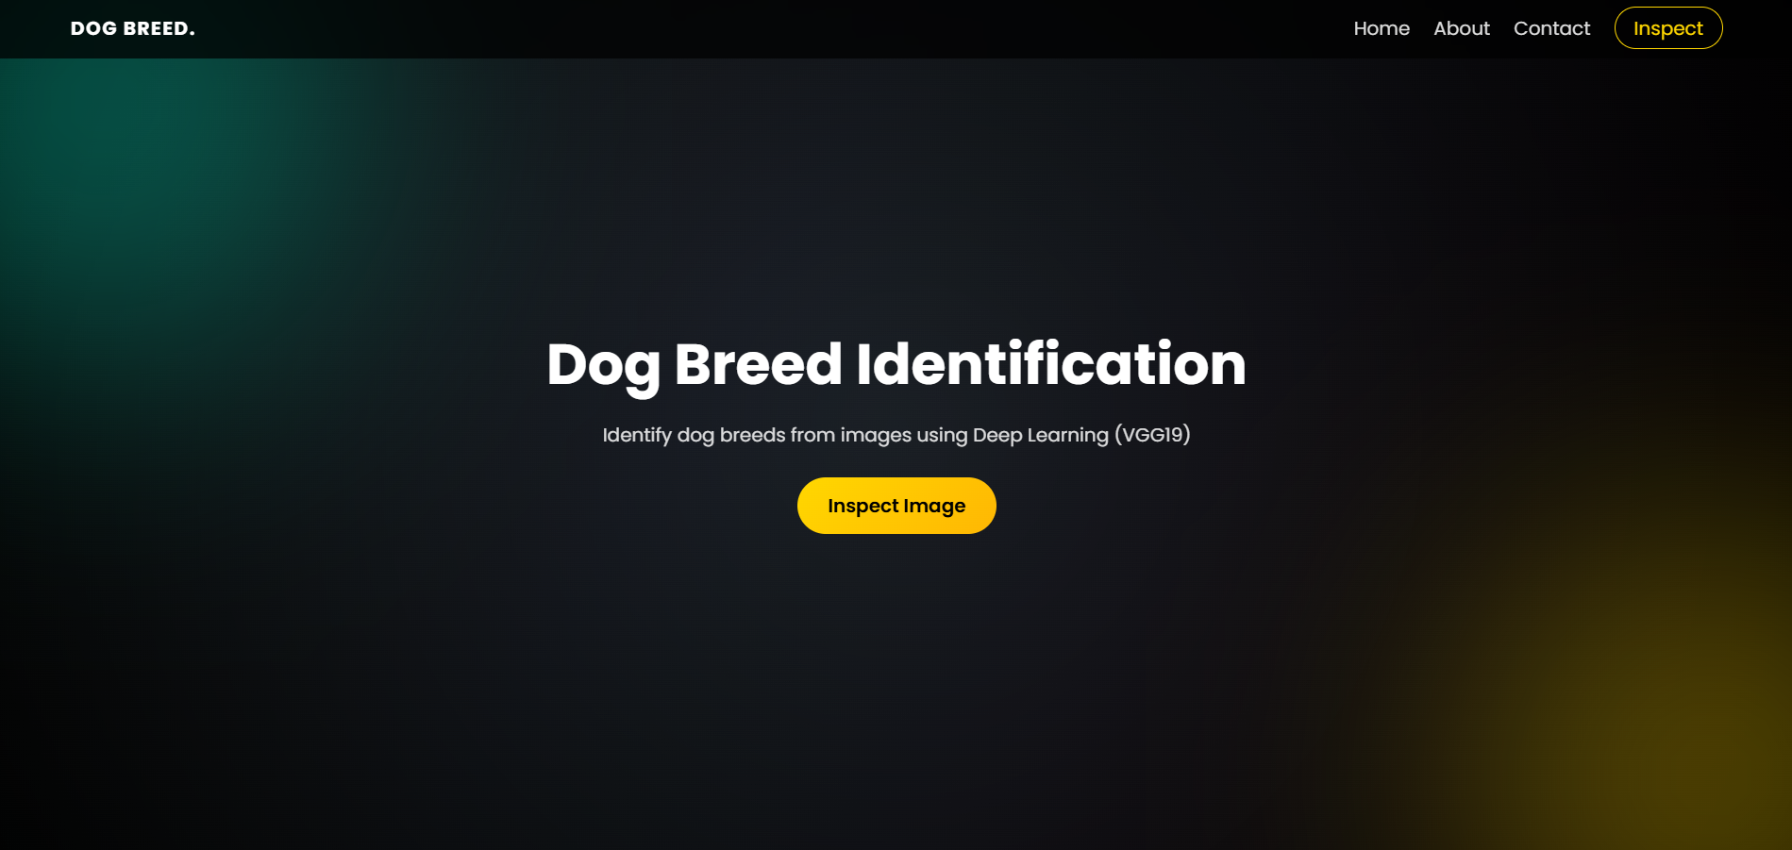

9. Testing
The system was tested at multiple levels to ensure correct functionality, model reliability, and smooth user experience.
Functional Testing
- Image upload functionality validation
- File format validation (JPG/PNG only)
- End-to-end flow testing (upload → prediction → result display)
- UI navigation and page rendering checks
Model Testing
- Training accuracy monitoring during model training
- Validation accuracy evaluation on unseen images
- Analysis of misclassifications between visually similar breeds
- Overfitting monitoring using training vs validation loss
Performance Testing
- Response time measurement for image upload and inference
- Prediction time evaluation for real-time usage
- Model loading time optimization at application startup
Edge Case Testing
- Invalid file uploads (non-image files)
- Corrupted or low-quality images
- Empty upload requests
- Extremely small or large image sizes
The system performed reliably under normal operating conditions, and appropriate error handling was implemented to manage invalid inputs gracefully.

10. Known Issues
- Model training is computationally intensive and benefits significantly from GPU acceleration; training on CPU may take longer.
- Prediction accuracy depends on the quality, lighting, and clarity of the uploaded dog images. Low-resolution or blurred images may lead to incorrect predictions.
- The current deployment is limited to a local Flask server and is not yet hosted on a cloud platform for public access.
- The model is trained on a limited number of dog breeds, which may affect generalization to unseen or mixed breeds.
- The application does not maintain user history or session-based personalization in the current version.
Future versions may address these limitations through cloud deployment, dataset expansion, performance optimization, and additional user-focused features.

11. Future Enhancements
Several improvements can be implemented to further enhance the Dog Breed Identification System:
- Deploy the application on cloud platforms such as AWS, Azure, or Render for public access and scalability.
- Expand the dataset to include more dog breeds and mixed-breed samples to improve generalization and accuracy.
- Integrate model explainability techniques (e.g., Grad-CAM) to visualize which parts of the image influence breed predictions.
- Add a mobile application version to allow users to capture and upload images directly from smartphones.
- Implement real-time camera-based prediction for instant breed identification.
- Introduce user profiles and prediction history for personalized tracking (optional feature).
- Optimize model performance using lighter architectures (e.g., MobileNet) for faster inference on low-resource devices.
- Enable API endpoints for third-party integration with pet adoption platforms and veterinary systems.
These enhancements can improve accessibility, scalability, interpretability, and overall user experience of the system.

12. Conclusion
The Dog Breed Identification System successfully demonstrates the integration of Deep Learning with web technologies for real-time image classification. By leveraging the VGG19 convolutional neural network through transfer learning, the system effectively identifies dog breeds from uploaded images with reliable accuracy.
The integration of the trained deep learning model with a Flask-based web application provides a simple, interactive, and user-friendly interface for users to upload images and receive instant predictions along with confidence scores. This end-to-end implementation highlights the practical application of Artificial Intelligence in the domain of animal welfare and pet adoption support.
The project showcases how AI-driven computer vision solutions can be translated into deployable web applications with real-world usability. With further enhancements such as cloud deployment, dataset expansion, and mobile integration, the system can be scaled to support wider adoption by pet adoption platforms, veterinary clinics, and animal welfare organizations.

